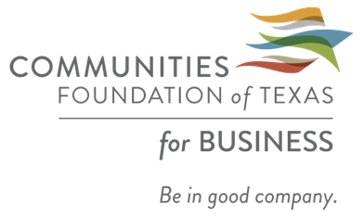
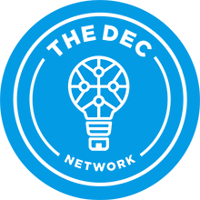
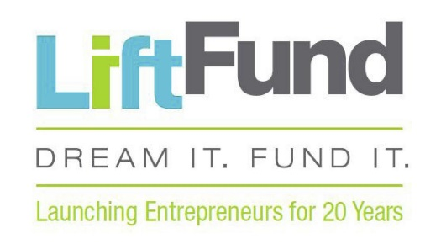

REVIVE DALLAS
SMALL BUSINESS RELIEF FUND
DOCUMENT CHECKLIST
- Was my company established before August 2019?
Enter date of registration at the county or state level: _______________
If you are a sole proprietor operating with a “dba”, provide a copy of your business name registration with the county.
If operating as a corporation, provide copy of registration with the Texas Secretary of State. You can also visit https://mycpa.cpa.state.tx.us/coa/ to get a current print out of your company’s status with the Texas Comptroller of Public Accounts.

- Number of Employees: 2019 ________ 2020 (Jan 1st – Mar 1st) _________

- Are you a minority owned business? YES / NO (Circle)

- Are you a certified minority owned business? YES / NO
If yes, please provide us with a copy of your Minority Owned Business Certification.
- Annual Gross Revenue for Fiscal Year
2019
Jan 1st – March 31st | April 1st – June 30th | July 1st – Sept 30th | Oct 1st – Dec 31st
2020
Jan 1st – Feb 29th |  | March 1st – June
Provide a copy of your tax returns for 2018 and 2019
- You must have been in good standing with your creditors.
Provide us with an updated Accounts Payable Aging.
Company Name | Contact Name | Phone Number | E-mail

- Which bank do you currently bank with? ______________________________
Provide us bank statements from January 1st, 2020 through May 2020
You can easily obtain these statements by logging into your bank’s online portal, printing them or saving them directly into your computer as PDF files.

- Plan of Action.
Provide us with a plan of action detailing monthly projections of the business along with initiatives being implemented to reach your specific goals.

